---------------------------------------------------------------------

-- LAB 06

--

-- Exercise 2

---------------------------------------------------------------------

USE TSQL;

GO

---------------------------------------------------------------------

-- Task 1

--

-- Write a SELECT statement to retrieve distinct values for the custid column from the Sales.Orders table.

-- Filter the results to include only orders placed in February 2008.

-- Execute the written statement and compare the results that you got with the desired results shown in the file 62 - Lab Exercise 2 - Task 1 Result.txt.

---------------------------------------------------------------------

---------------------------------------------------------------------

-- Detyra 1

--

-- Gjeni vlerat unike per kolonen custid nga tabela Sales.Orders. Filtroni rezultatet per te perfshire vetem porosite te kryera ne Shkurt te 2008.

-- Ekzekutoni veprimet e mesiperme dhe krahasoni rezultatet qe ju moret me rezultatet e deshiruara te treguara ne dokumentin 62-Lab Exercise 2- Task 1 Result.txt.

---------------------------------------------------------------------

Select so.custid ,so.orderid,DATEPART(year,so.orderdate) as year,DATEPART(month,so.orderdate) as month

FROM Sales.Orders as so WHERE DATEPART(year,so.orderdate) = 2008 and DATEPART(month,so.orderdate) = 2

Order BY so.custid

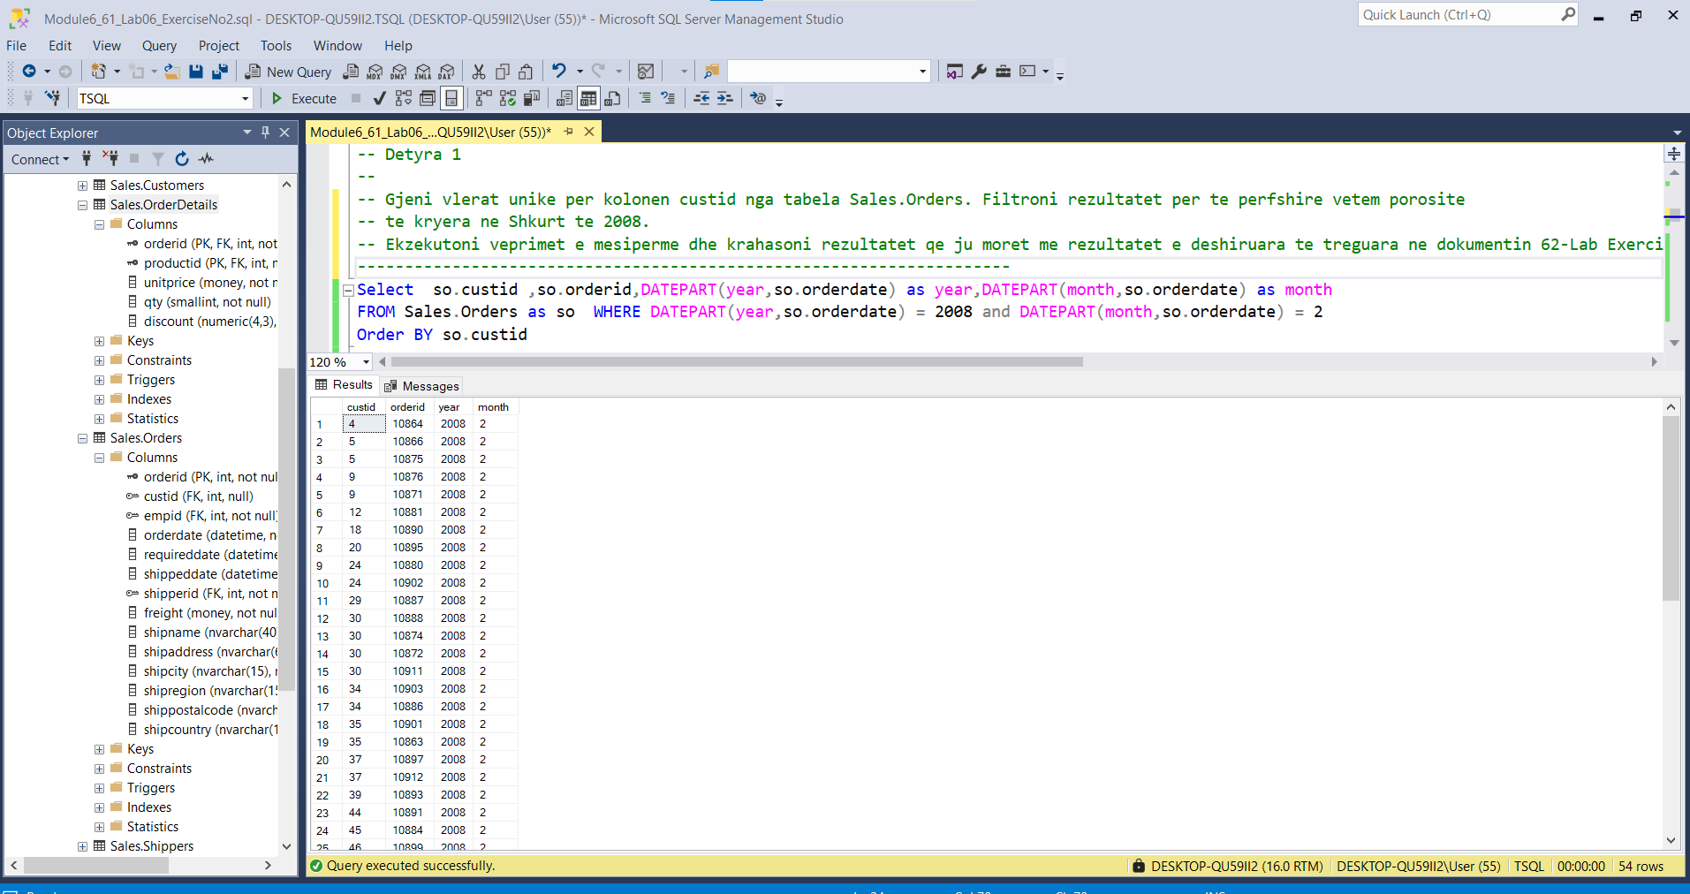

---------------------------------------------------------------------

-- Task 2

--

-- Write a SELECT statement with these columns:

-- Current date and time

-- First date of the current month

-- Last date of the current month

--

-- Execute the written statement and compare the results that you got with the recommended result shown in the file 63 - Lab Exercise 2 - Task 2 Result.txt. The results will differ because they rely on the current date.

---------------------------------------------------------------------

---------------------------------------------------------------------

-- Detyra 2

--

--Selektoni keto kolona:

--1-- Data dhe koha aktuale

--2-- Daten e pare te muajit aktuale

--3-- Daten e fundit te muajit aktuale

--4- Ekzekutoni veprimet e mesiperme dhe krahasoni rezultatet qe ju moret me rezultatet e

rekomanduara ne dokumentin 63-Lab Exercise 2- Detyre 2 Results.txt. Rezultate do

jene te ndryshme sepse ato varen ne daten aktuale.

---------------------------------------------------------------------

--1--

Select CAST(GETDATE() AS DATE) as dataAktuale, CONVERT(time,getdate()) as kohaAtuale

--ose--

SELECT CAST(GETDATE() AS DATETIME) as data_kohaAktuale

--2--

SELECT DATEFROMPARTS(year(GETDATE()),month(GETDATE()),'01') as dite_PareMuajiAktual

--3--

SELECT EOMONTH((GETDATE())) as dita_funditMuajiAktual

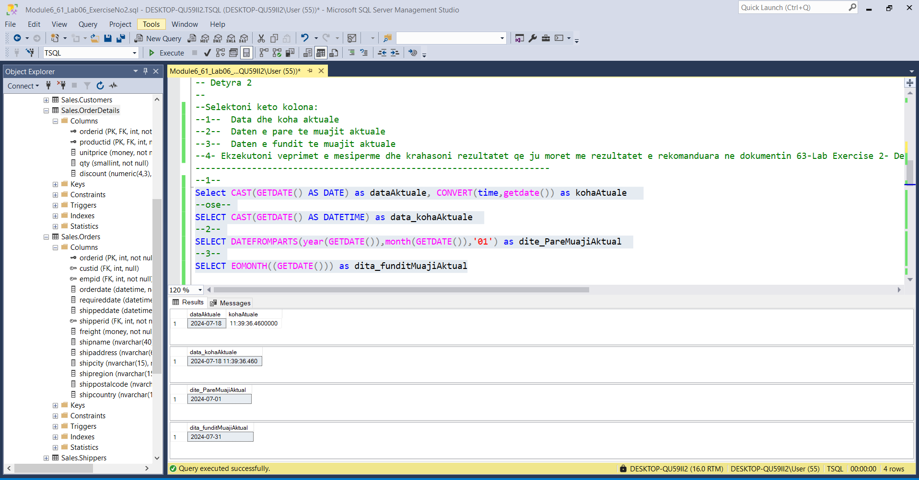

---------------------------------------------------------------------

-- Task 3

--

-- Write a SELECT statement against the Sales.Orders table and retrieve the orderid, custid, and orderdate columns.

-- Filter the results to include only orders placed in the last five days of the order month.

-- Execute the written statement and compare the results that you got with the recommended result shown in the file 64 - Lab Exercise 2 - Task 3 Result.txt.

---------------------------------------------------------------------

---------------------------------------------------------------------

--1--

Select so.orderid,so.custid,so.orderdate

From Sales.Orders as so Order By so.orderdate DESC

--2--

Select so.orderid,so.custid,so.orderdate as OrderDate

From Sales.Orders as so

WHERE so.orderdate between DATEADD(DAY,-5,EOMONTH(so.orderdate)) and EOMONTH(so.orderdate)

Order By so.orderdate DESC

---------------------------------------------------------------------

--1--

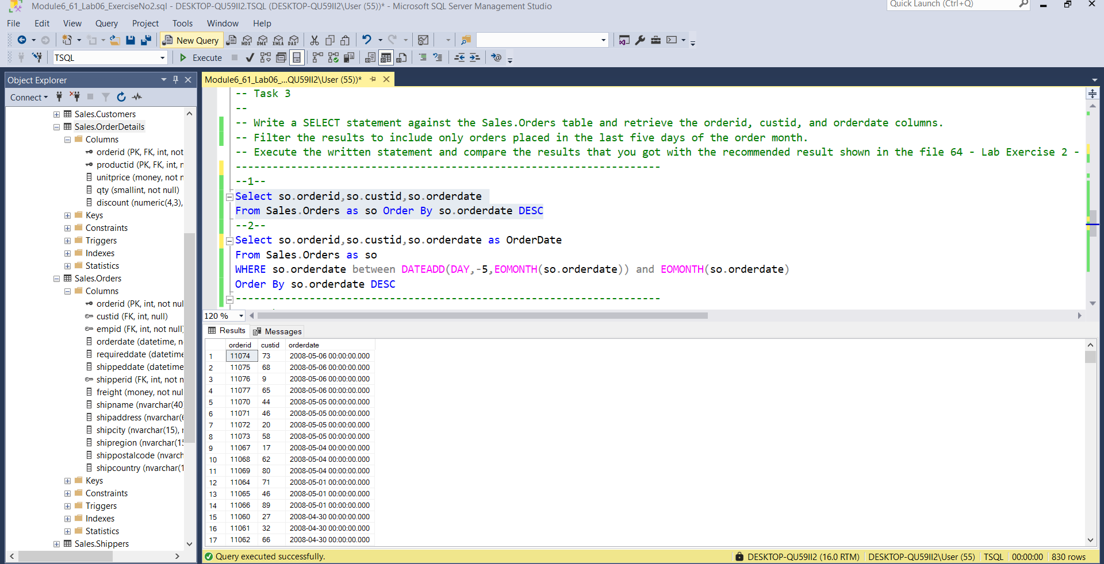

--2--

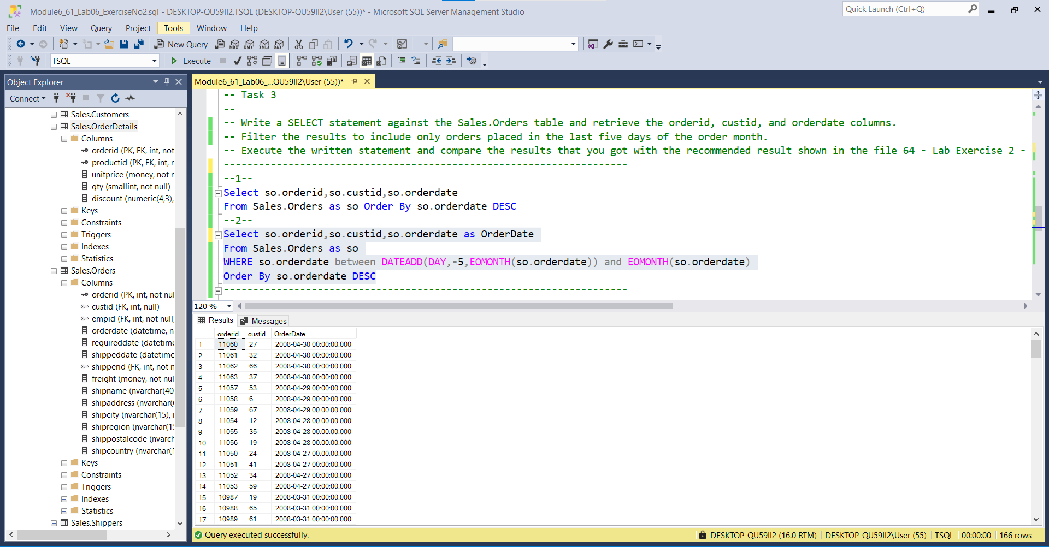

-- Task 4

--

--1-- Write a SELECT statement against the Sales.Orders and Sales.OrderDetails tables and retrieve all the distinct values for the productid column.

--2-- Filter the results to include only orders placed in the first 10 weeks of the year 2007.

--3-- Execute the written statement and compare the results that you got with the recommended result shown in the file 65 - Lab Exercise 2 - Task 4 Result.txt.

------------------------------------------------------------------------------------------------------------------------------------------------------------------------------------

--1--Distinct values for productId

SELECT DISTINCT sod.productid

FROM Sales.Orders as so INNER JOIN Sales.OrderDetails as sod ON so.orderid = sod.orderid

ORDER BY sod.productid

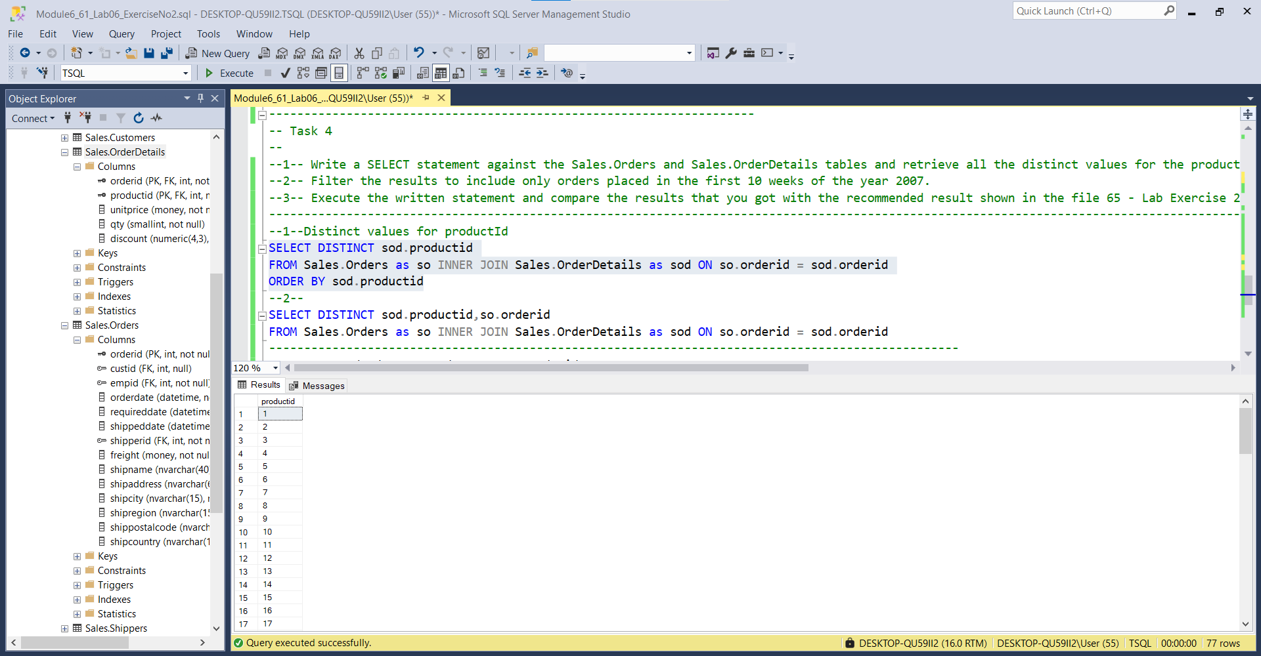

--2--

SELECT DISTINCT sod.productid,so.orderid

FROM Sales.Orders as so INNER JOIN Sales.OrderDetails as sod ON so.orderid = sod.orderid

-----------------------------------------------------------------------------------------

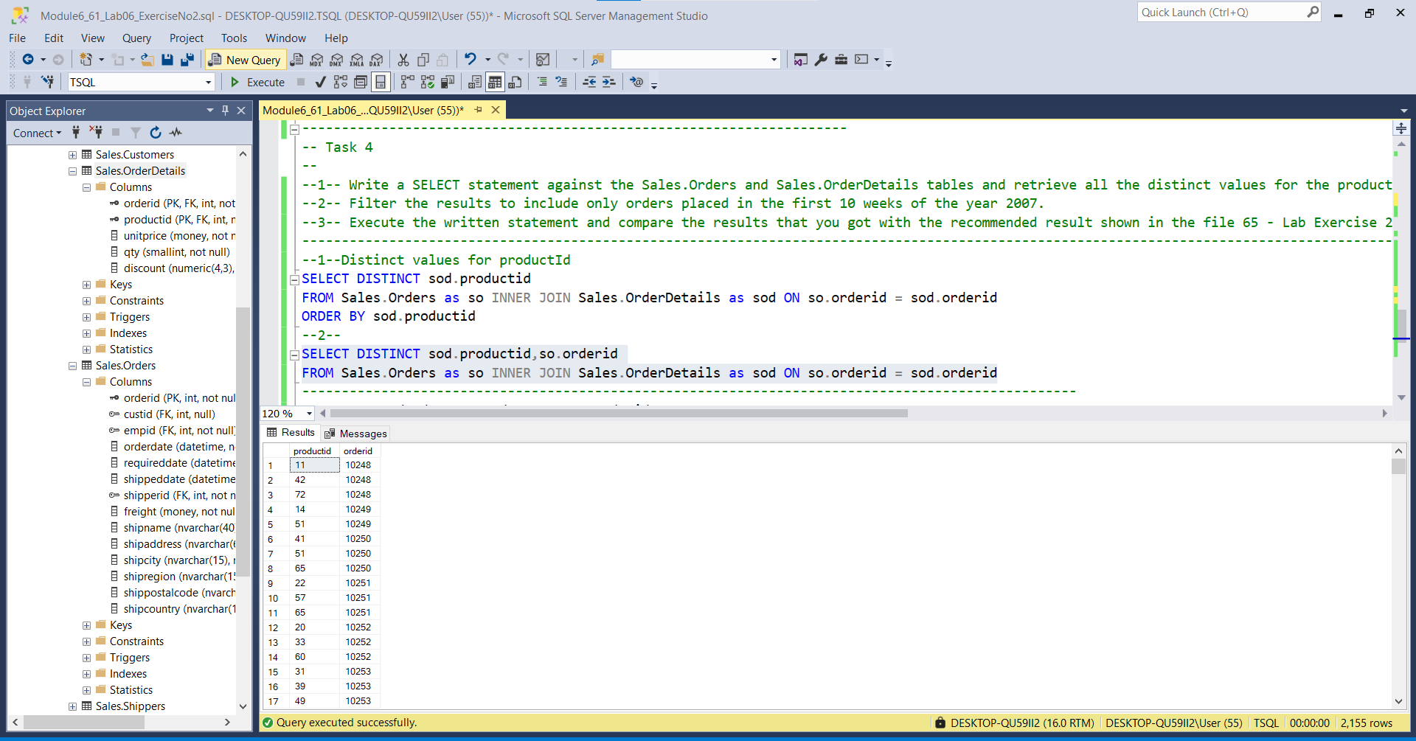

SELECT so.orderdate as OrderDate ,so.orderid

From Sales.Orders as so

WHERE so.orderdate between DATEFROMPARTS('2007','01','01') And DATEADD(week,10,'2007-01-01')

